Event/Activity Name | Cultural Insights: India Vs. USA
Dept. Name | Management
Date of Event/Activity | 08/01/2025
Time of Event/Atcitty | 10.00 AM to 11.00 AM
Event purpose/motive | To give insights to students regarding cultures of USA and India
No. of Participants | 100
Location | GF 28
Expert details (if) | Er. Cyber Security USA
Brief About Event/Activity (min. 200 Words) | Mr. Malay Patel, a cyber security engineer in the USA, delivered an insightful talk on the cultural differences between the USA and India. During the session, he highlighted the distinct contrasts in workplace cultures, communication styles, and work ethics between the two countries. He shared how these cultural differences shape professional environments, particularly in the cyber security sector. Mr. Patel also discussed the impact of social norms, family values, and educational systems on personal and professional development in both countries. The talk offered valuable insights into navigating cross-cultural challenges in the global workforce.
Event/Activity Coordinator Name | Tulsi Kondhiya
Minutes of the event | - Welcome and Introduction  - Introduction of Mr. Malay Patel, cyber security engineer in the USA.  - Overview of the topic: Cultural differences between the USA and India.  - Keynote Presentation  - Cultural differences in the workplace (USA vs. India).  - Communication styles: Direct vs. indirect.  - Impact on the cyber security sector: Risk management and collaboration.  - Social norms and family values: Individualism vs. collectivism.  - Education systems and skill development.  - Audience Interaction and Q&A  - Discussion on cross-cultural teamwork, leadership, and career growth.  - Closing Remarks  - Appreciation for Mr. Patel’s insights.  - Encouragement to apply cultural awareness in professional settings.  - Adjournment  - Session concluded with final thoughts on navigating cross-cultural dynamics.
Two Photograph without Gio-Tag

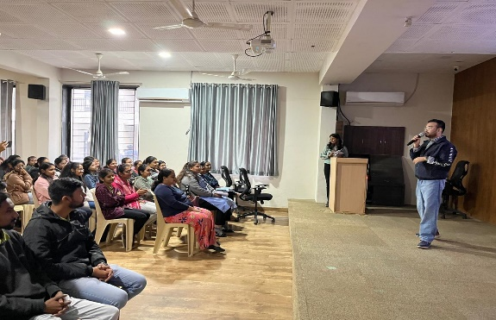
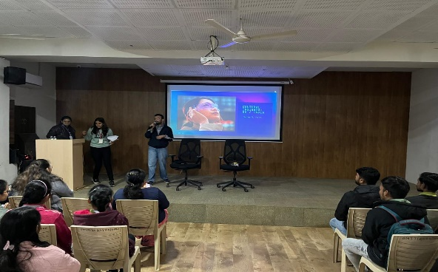

Department HOD Name | Dr. Mandeep Majmudar
Remarks:

Event/Activity feedbacks by faculty or students (if have any)

Note: Event/Activity forms must be submitted within 2 days with Canva post/Reel. (Soft copy-word)

